Software Engineering Project 2

# FilmGenie Game:

## Sample Run 1:

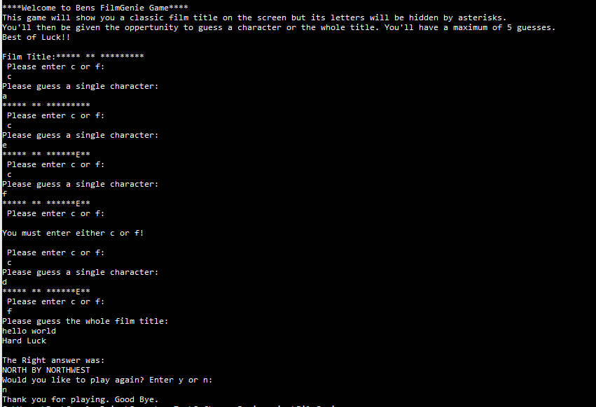

## Sample Run 2:

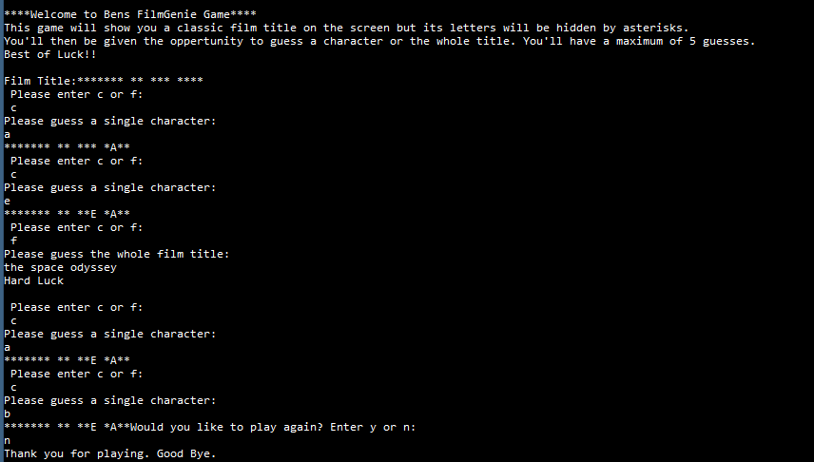

## Sample Run 3:

